Lab 3 – Extensive Practice – Replicating Pages

1. Twitter Login Page (Twitter.com)

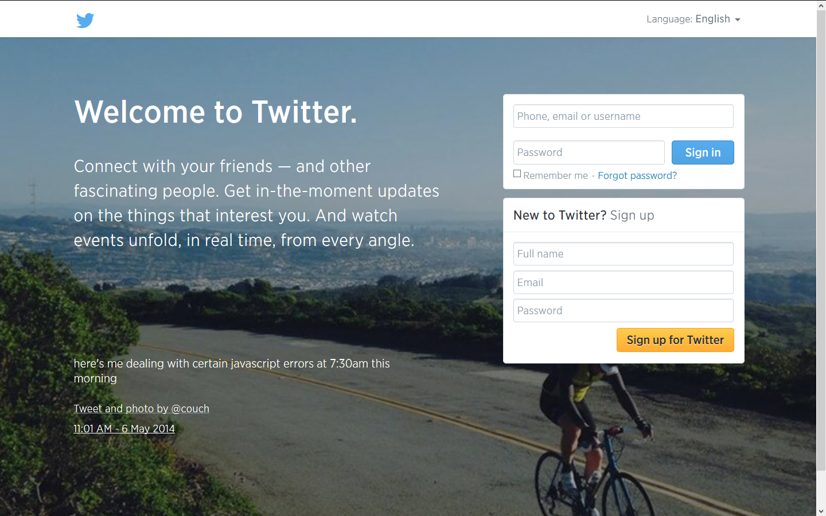

1. Create a complete design of Path.com in Bootstrap. All pages should be present as those on Path.com site!
2. Create a complete replica of Gitter.com (Note that ignore the chat capability – just replicate the design using Bootstrap )
3. Create the following pages
4. <https://www.parse.com/about>
5. <https://www.parse.com/plans> (Add Interactivity via jQuery or Bootstrap Constructs)
6. Replicate the following Pages

https://www.linkedin.com/

<http://developer.linkedin.com/>